HIGH PRESSURE DETECTION

PROJECT

**Ismail Tarek Elsayed**

* **Case Study:**

Client expects to have a software that it’s system gives the following:

A pressure detection system that informs the crew of a cabin with an alarm when the pressure exceeds 20 bars in the cabin.

The alarm duration will be 60 sec.

* **Assumptions:**
* controller setup and shut down procedures are not modeled.
* controller maintenance is not modeled.
* pressure sensor never fails.
* alarm never fails.
* controller never faces power cut.
* **H.W and S.W Partitioning:**
* Hardware:

1. STM32F103C6.
2. LED
3. Pressure sensor

* Software

1. Main algorithm
2. Alarm driver
3. App
4. Pressure sensor driver

* **Requirement:**

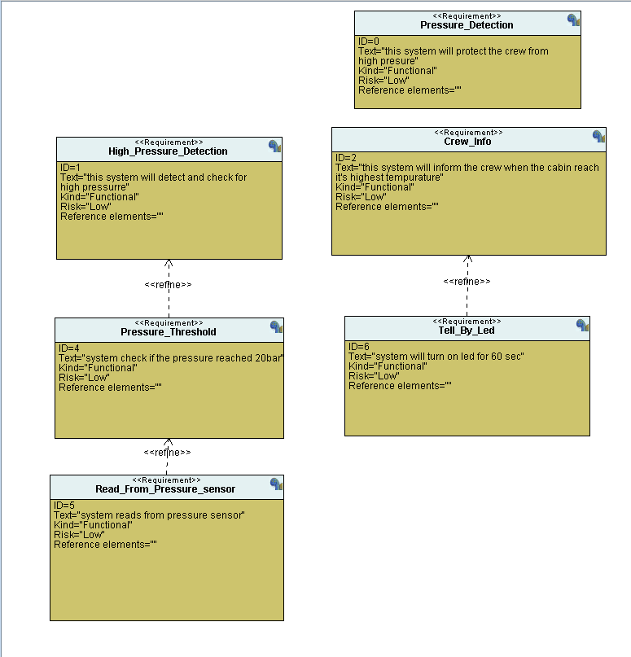

* **System Analysis:**
  + **Case Diagram:**

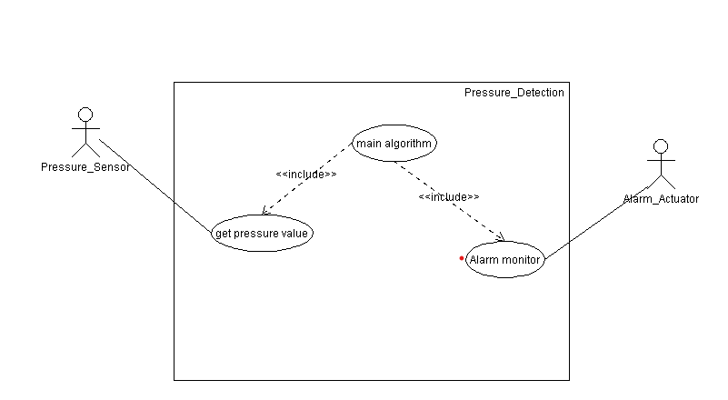

* + **Activity Diagram:**

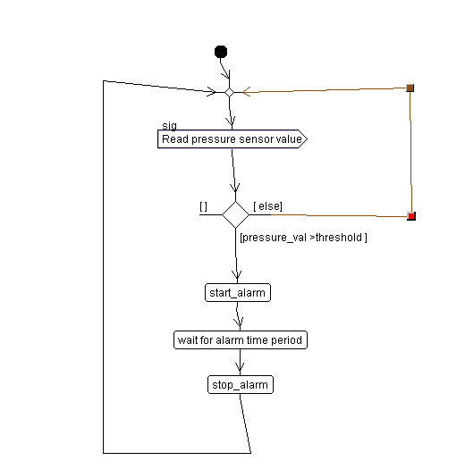

* + **My Scenario:**

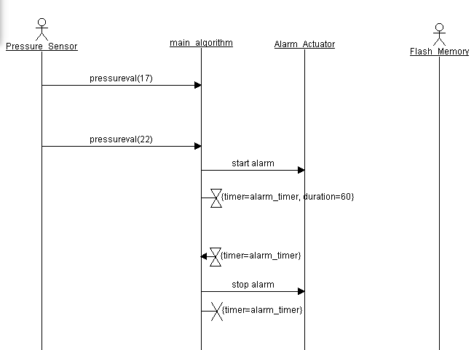

* **System Design:**

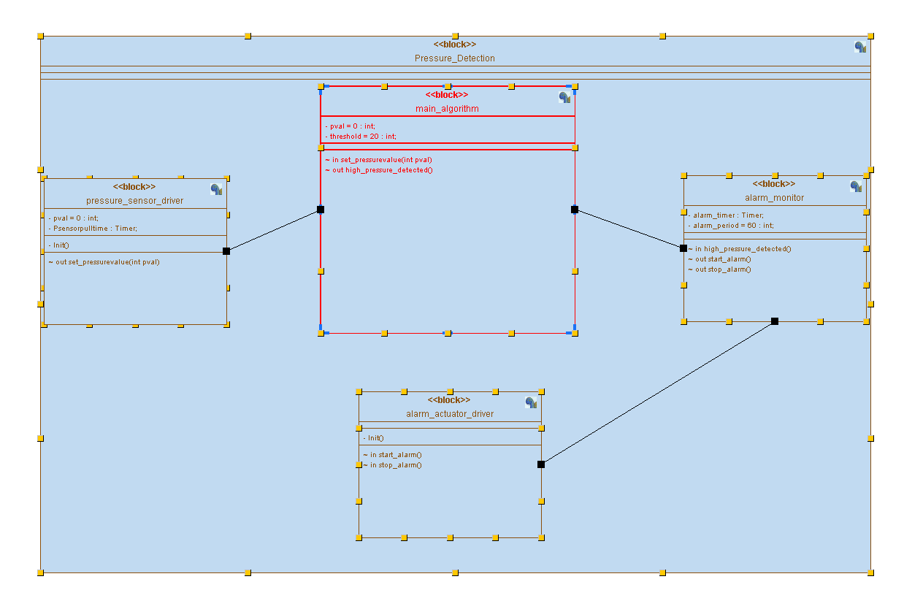

* + **Flow Charts:**

**Pressure Sensor. Alarm Monitor**

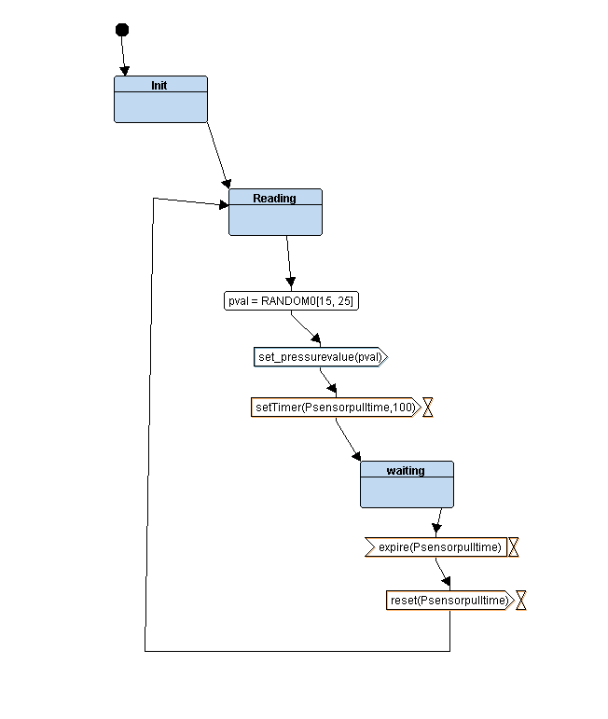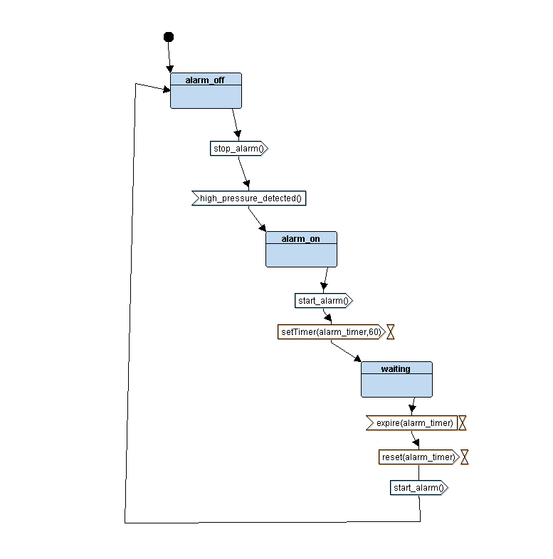

**Alarm Driver Main Algorithm**

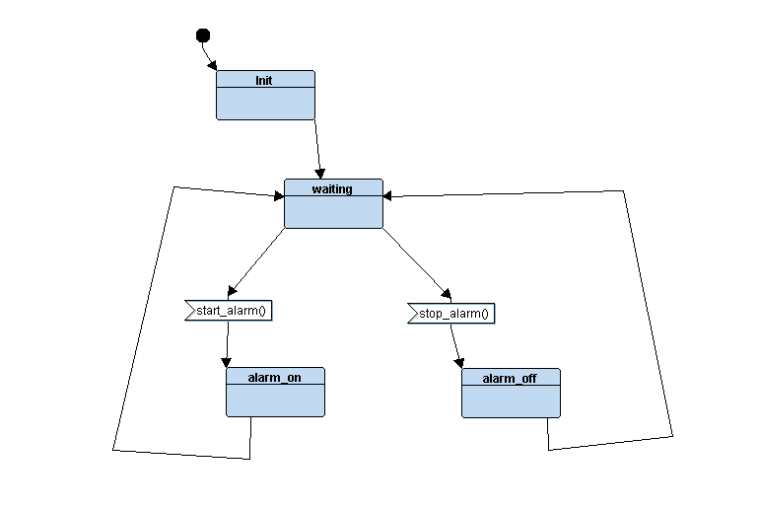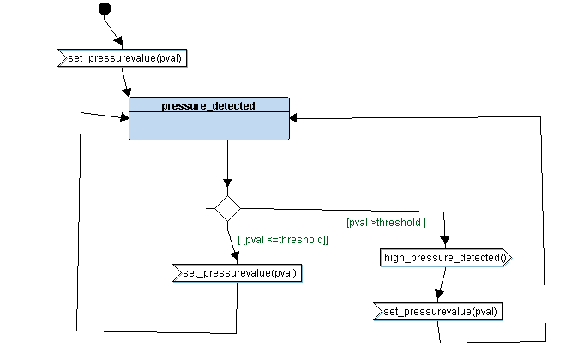

**Analysis Diagram:**

**When it exceed 20:**

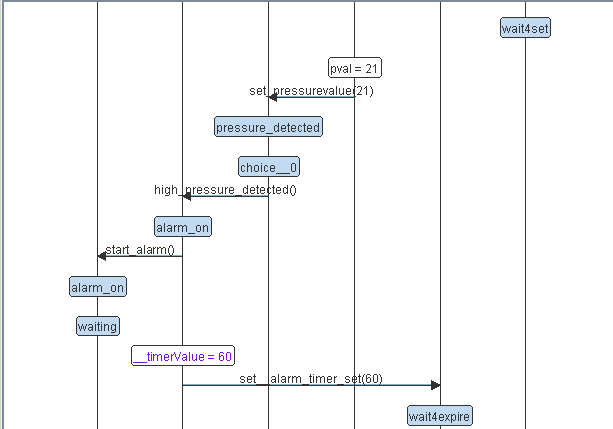

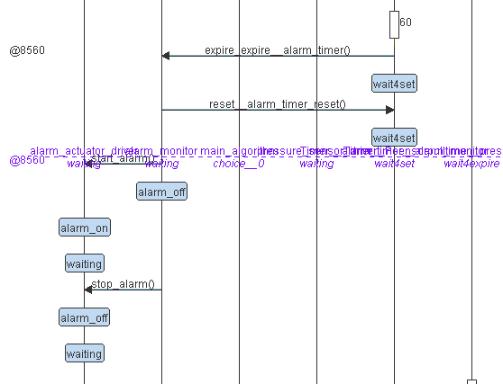

**When it’s below:**

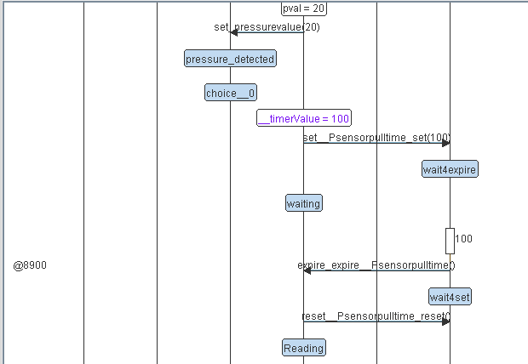

* **Project Build Proccess:**

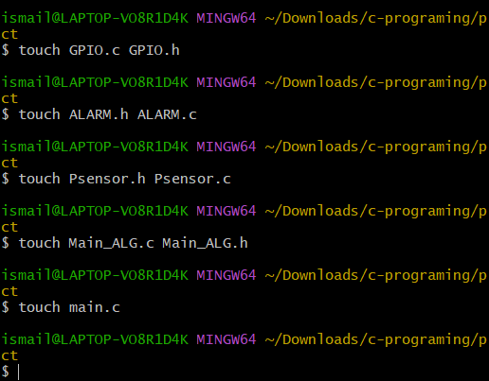

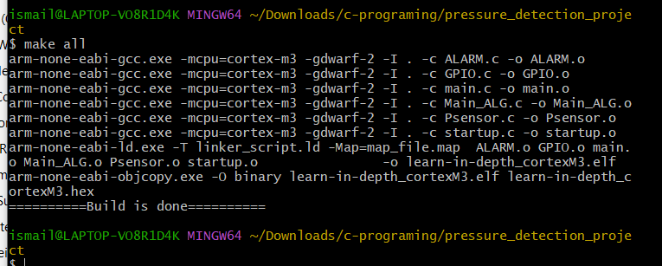

**Symbols:**

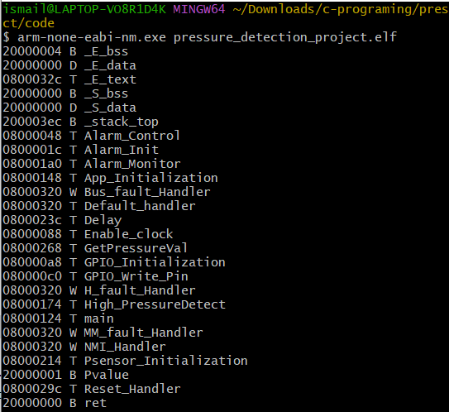

**Sections:**

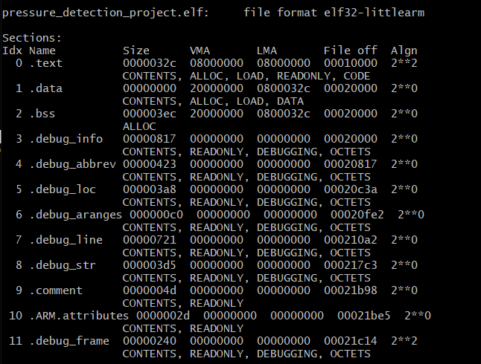

* **Proteus Simulation:**

when it exceed 20: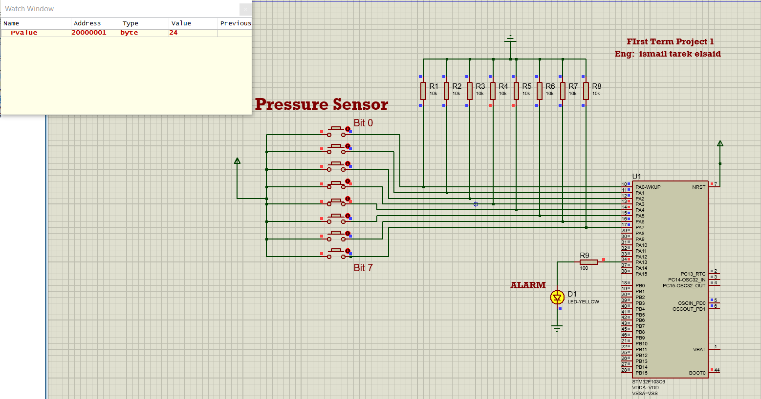

when it below 20:

